**Results for training the REL Model for the week 10th Oct – 14th Oct 2022**

The data preprocessing and testing of the .spacy files were being executed on Google Colaboratory.

The REL model was trained on tok2vec pipeline and 3 different transformers.

1. bert-base-uncased
2. bluebert_pubmed_uncased_L-12_H-768_A-12
3. bert-base-cased
4. roberta-base

The top 5 relations which we must focus are ['Has_value', 'Has_temporal', 'Has_qualifier', 'Subsumes', 'Has_scope'].

1. **The results of training REL model on top 5 relations:**

**a)** **Using CPU (tok2vec)**: When we run the command python -m spacy project run train_cpu, we get the results as follows:

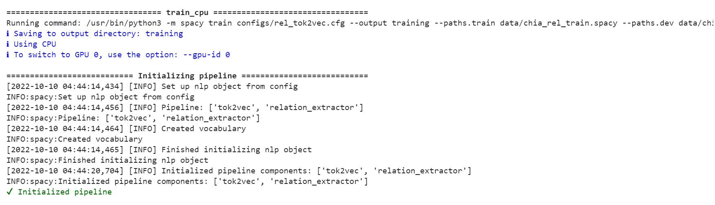

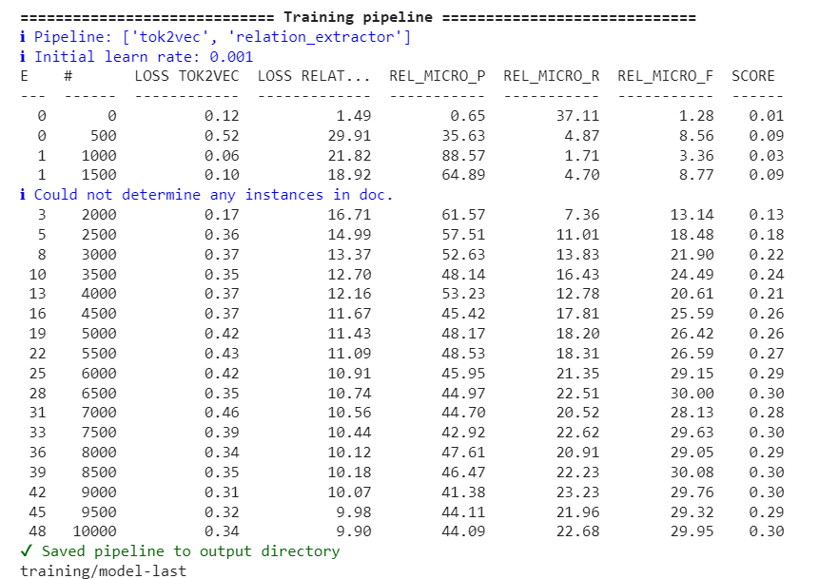

**The highest precision score for tok2vec pipeline is 88% with 48 epochs. The highest F1-score is 30%.**

When we run the command python -m spacy project run all, we get the results as follows:

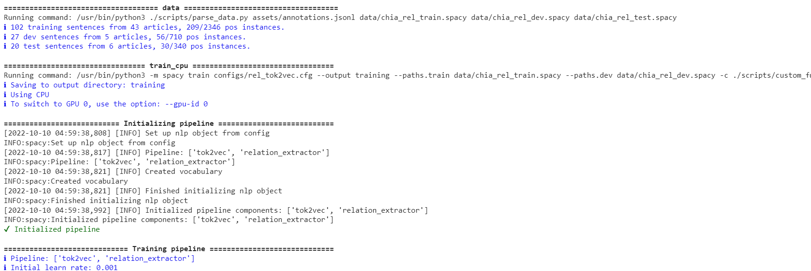

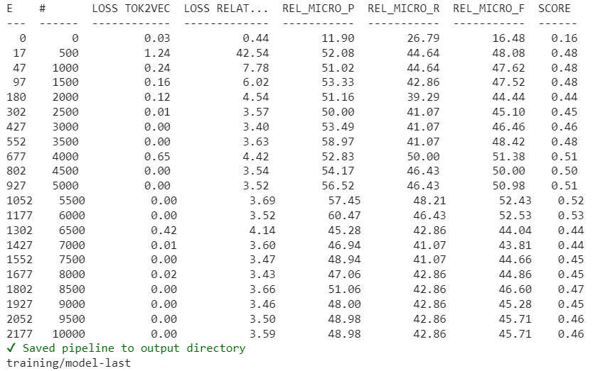

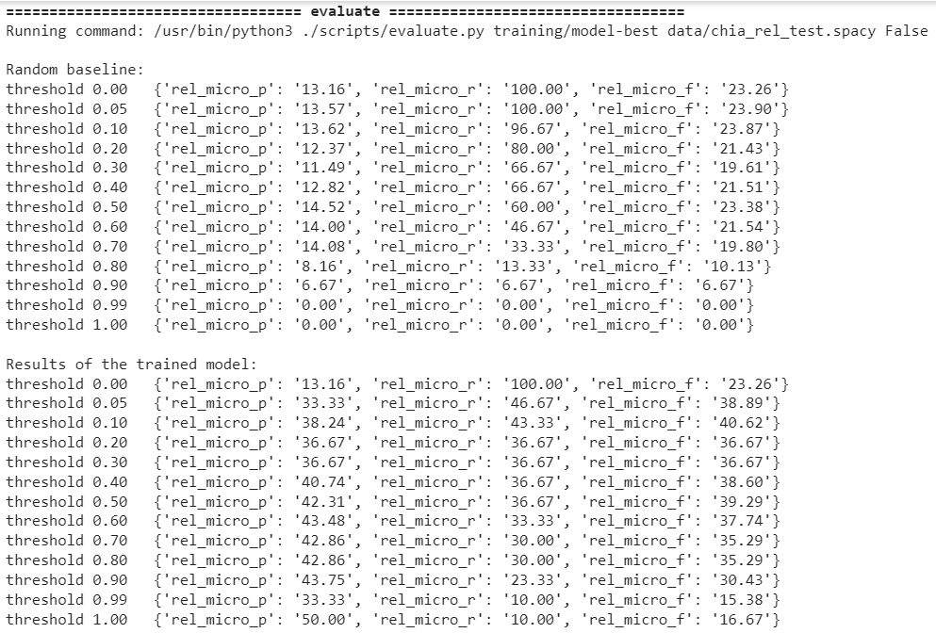

**b) Using GPU (Transformers):** **I) bert-base-uncased**: When we run the command python -m spacy project run train_gpu, we get the results as follows:

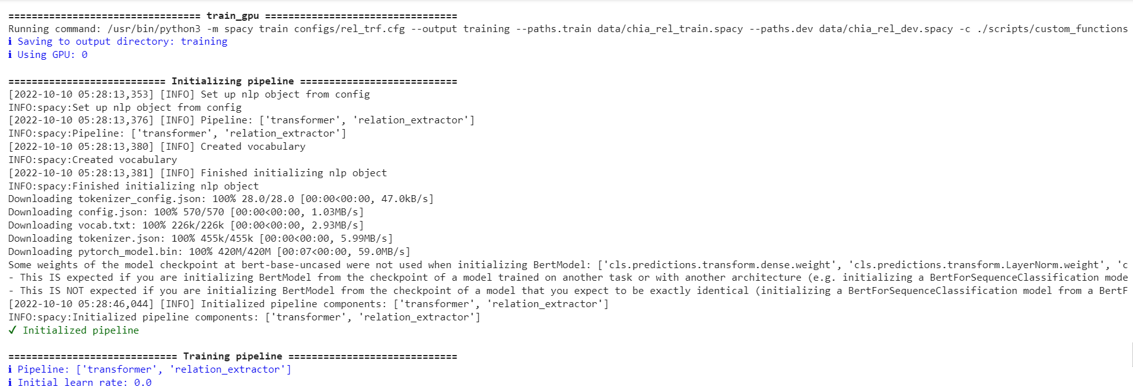

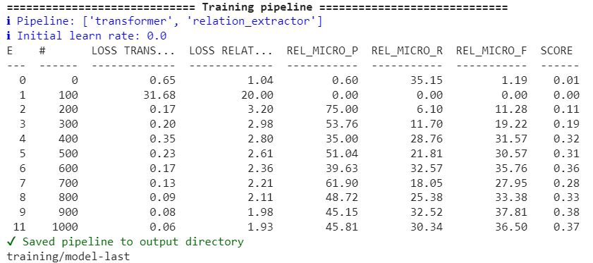

**The highest precision score for this transformer is 75% with 11 epochs. The highest F1-score is 38%.**

When we run the command python -m spacy project run all_gpu, we get the results as follows:

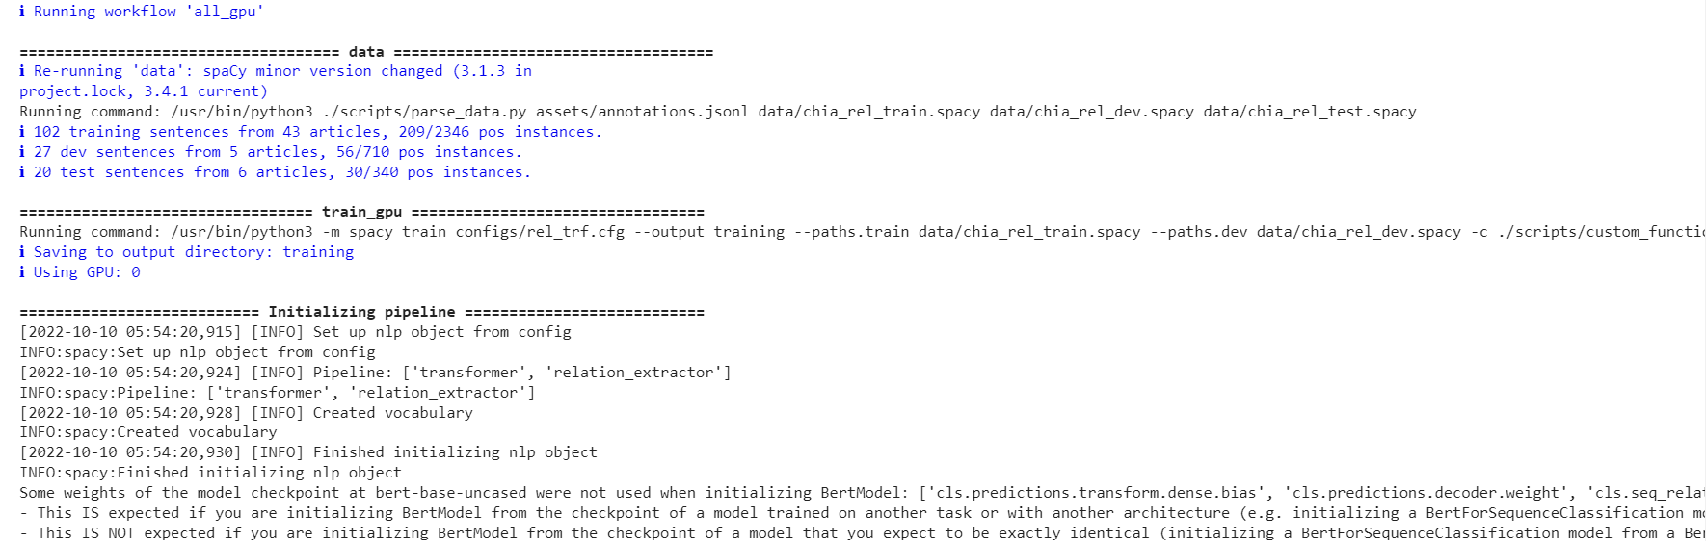

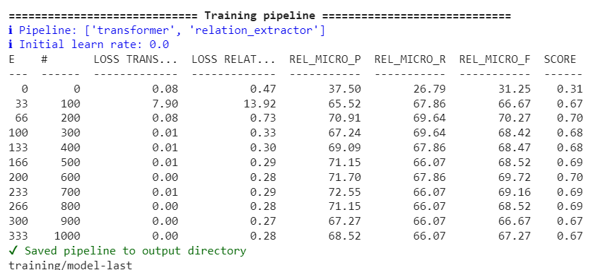

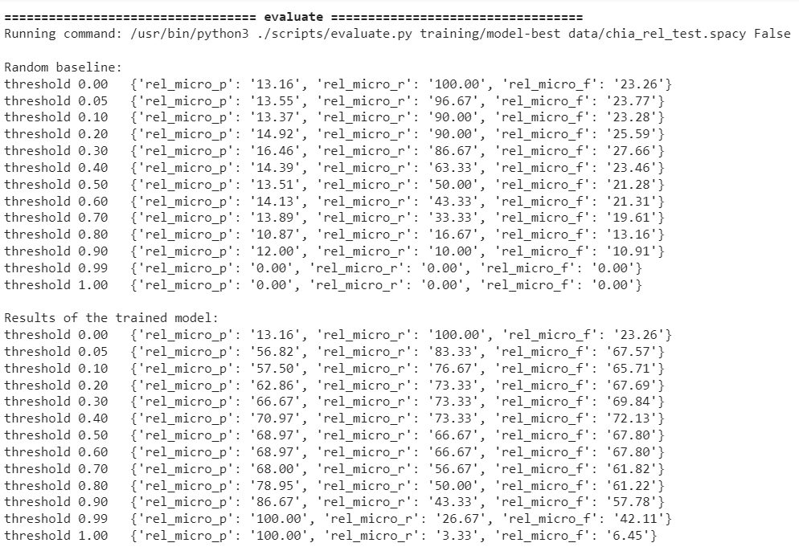

**II)** **bionlp/bluebert_pubmed_mimic_uncased_L-12_H-768_A-12**: When we run the command python -m spacy project run train_gpu, we get the results as follows:

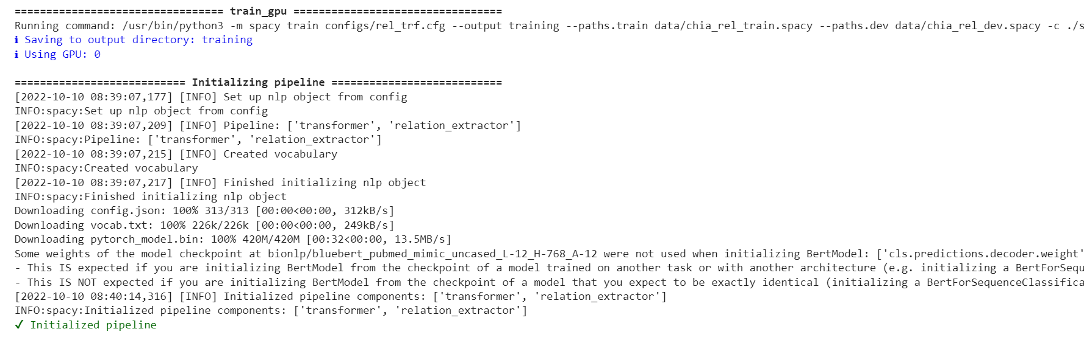

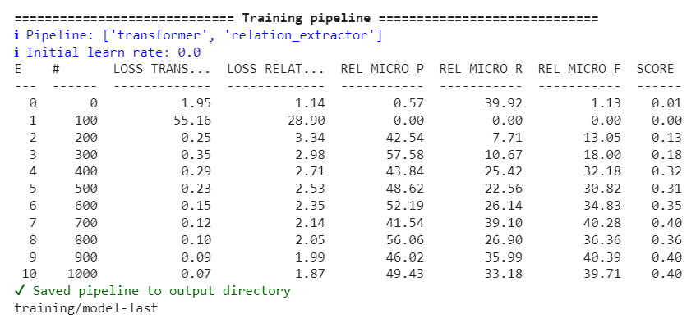

**The highest precision score for this transformer is 57% with 10 epochs. The highest F1-score is 40%.**

When we run the command python -m spacy project run all_gpu, we get the results as follows:

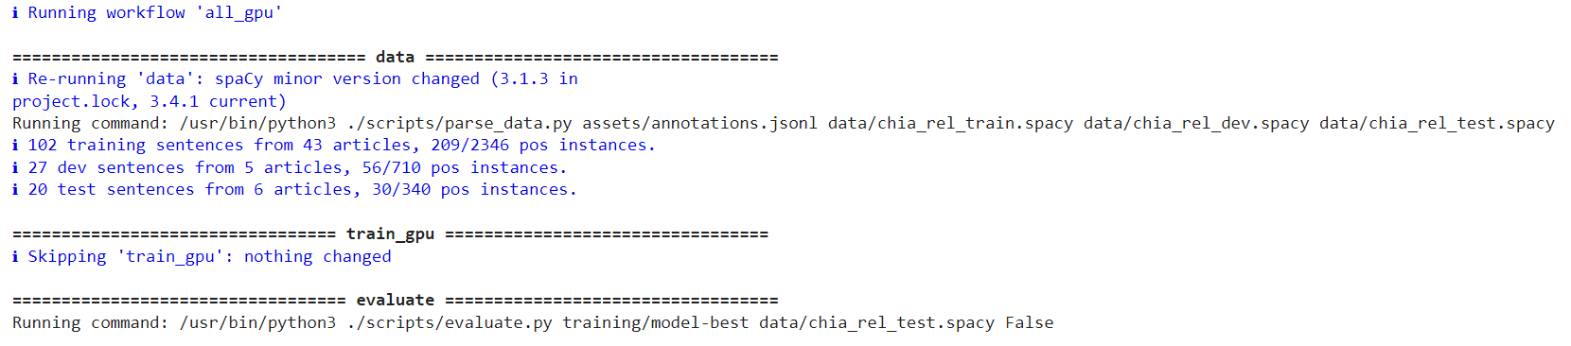

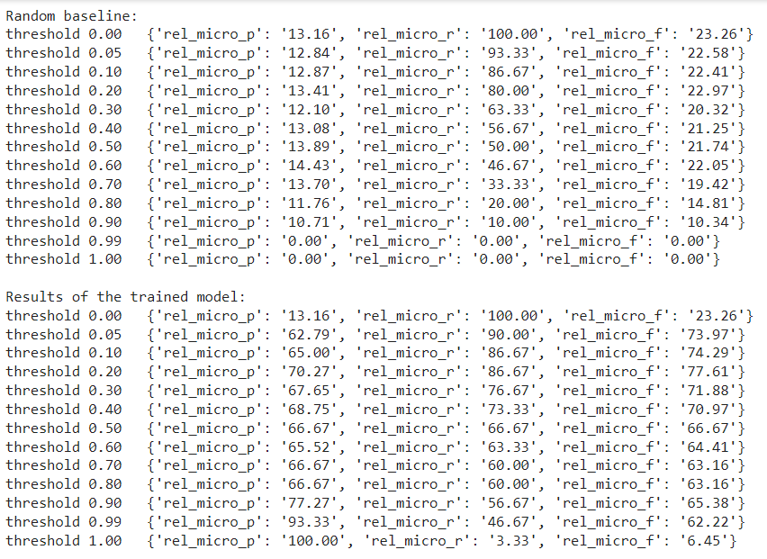

**III)** **bert-base-cased**: When we run the command python -m spacy project run train_gpu, we get the results as follows:

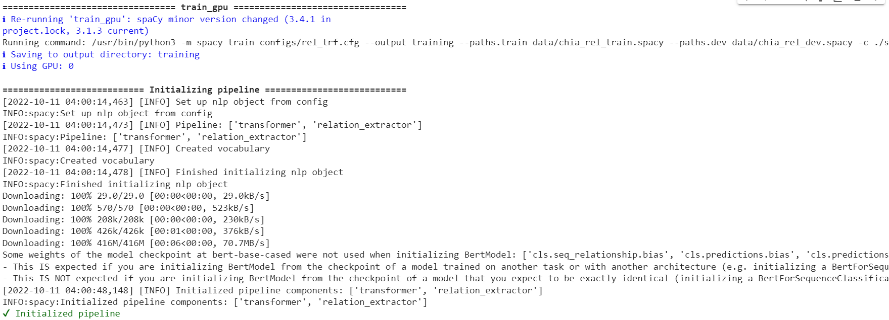

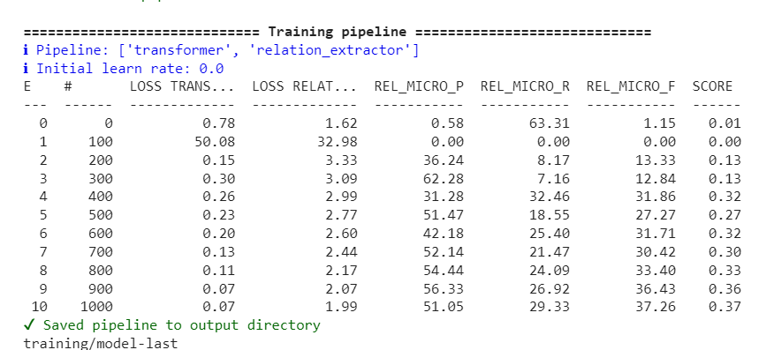

**The highest precision score for this transformer is 62% with 10 epochs. The highest F1-score is 37%.**

When we run the command python -m spacy project run all_gpu, we get the results as follows:

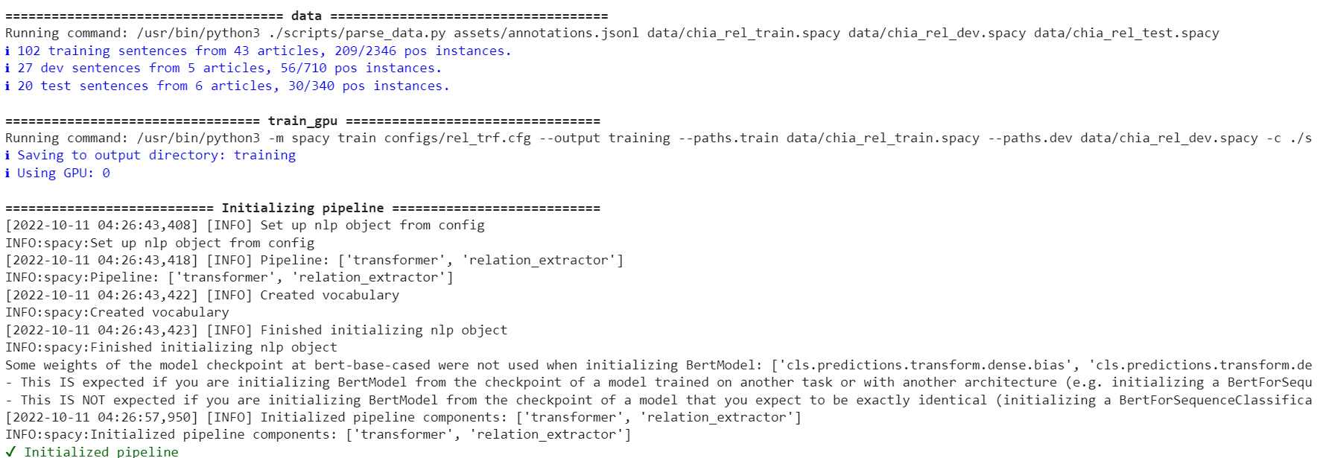

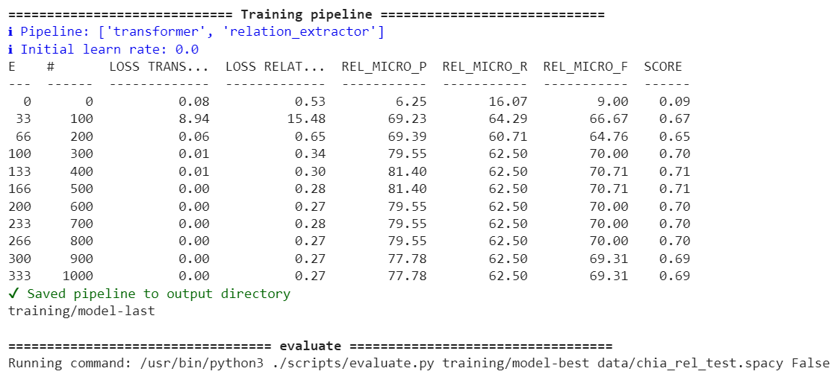

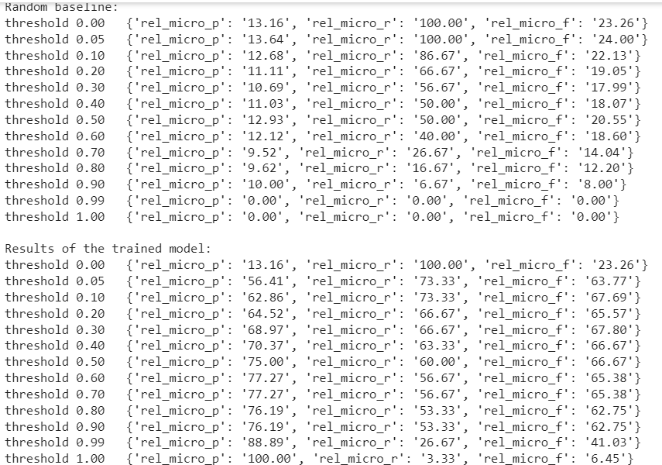

**IV)** **roberta-base**: When we run the command python -m spacy project run train_gpu, we get the results as follows:

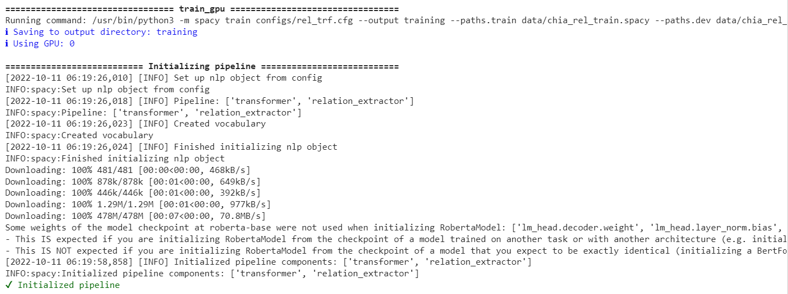

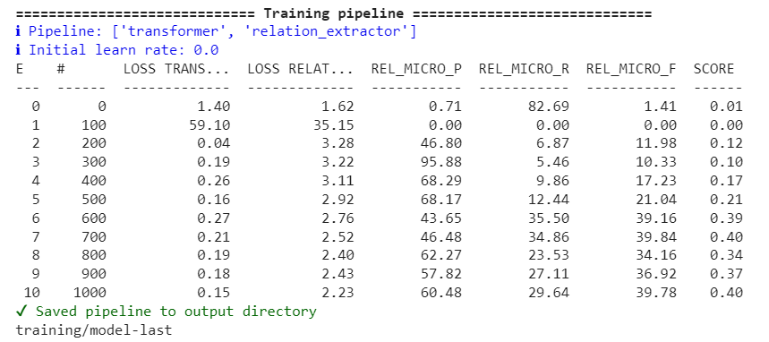

**The highest precision score for this transformer is 95% with 10 epochs. The highest F1-score is 40%.**

**Future Work**: The precision score of the trained REL model needs to be improved and will try increasing up to 80%.

**Note**: The training of REL model was initially performed on top 10 relations. Since the model performance did not improve, so we reduced our approach to just top 5 relations and ignored certain equivalence relations like AND, OR.

1. **The results of training REL model on top 10 relations:**

**Using CPU (tok2vec):** When we run the command python -m spacy project run train_cpu, we get the results as follows:

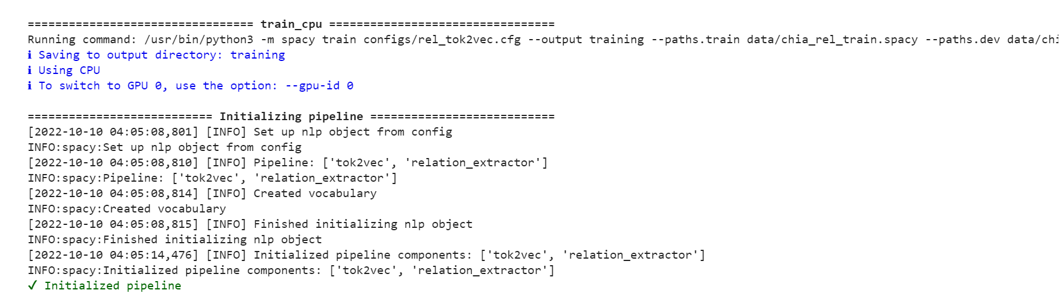

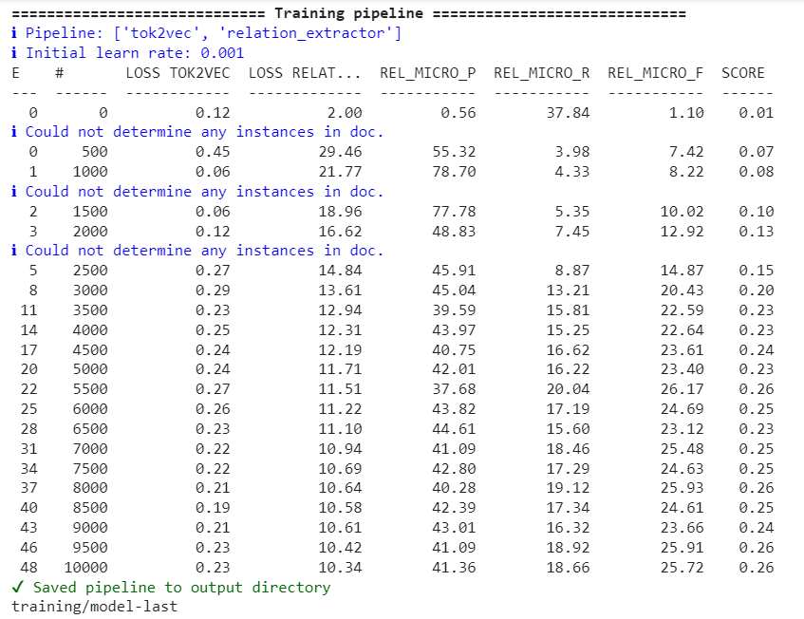

**The highest precision score for tok2vec pipeline is 78% with 48 epochs. The highest F1-score is 26%.**

When we run the command python -m spacy project run all, we get the results as follows:

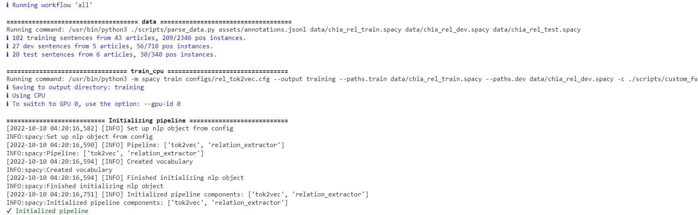

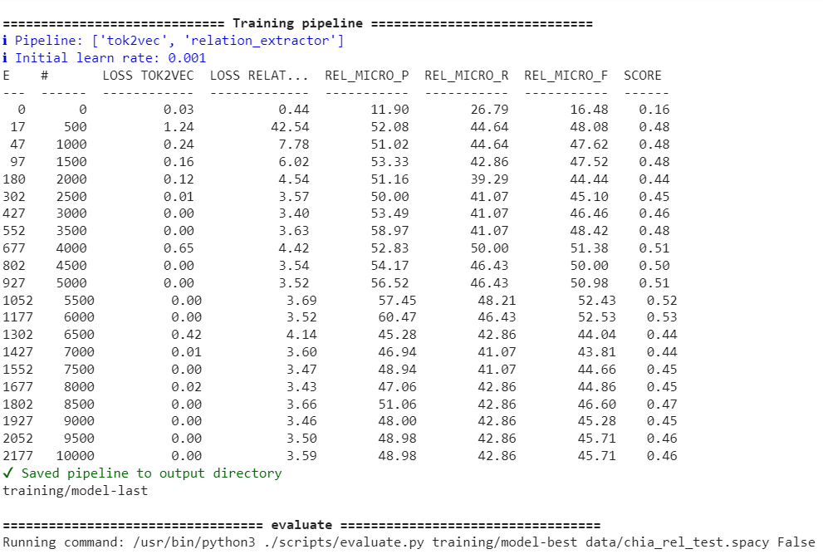 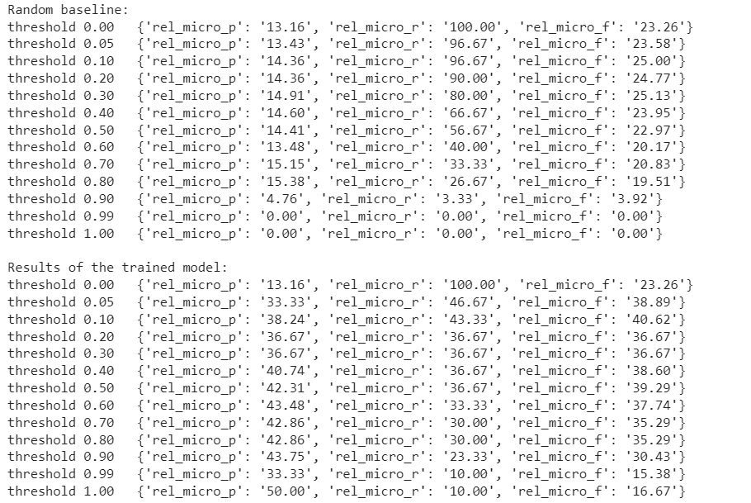

The next step was the saved REL models were being used for packaging purpose.

To perform the packaging on the REL models using Spacy follow these steps:

1. Use the rel_component repository from spacy explosions.
2. Inside this directory, create 2 folders **models** and **rel_models**.
3. Place the trained Chia REL model folder chia_roberta_5_rel inside the **models** directory.
4. Inside the chia_roberta_5_rel directory, open the meta.json file and edit **"name":"chia_rel_pipeline_trf".**
5. Inside command prompt, run this command to package the spacy model

**python -m spacy package models/chia_roberta_5_rel** **rel_models - -code list of comma separated custom component .py files.**

**e.g.** 1. python -m spacy package models/chia_roberta_5_rel/ rel-models/ --code scripts/rel_pipe.py, scripts/rel_model.py

1. This creates the **en_chia_rel_pipeline_trf-0.0.0** inside the **rel_models** directory.
2. Traverse to the directory **rel_models/en_chia_rel_pipeline_trf-0.0.0** and run the command: **python setup.py sdist**
3. It creates **dist** folder and inside it created **en_chia_rel_pipeline_trf-0.0.0.tar.gz** file.
4. Traverse to **dist** folder and run the command:

**python -m** **pip install** **en_chia_rel_pipeline_trf-0.0.0.tar.gz**

1. It will successfully install the trained Chia REL spacy model inside the system.
2. Validate it using the command: **python -m spacy validate**.

Tried out Serving the saved REL model using FastAPI.

**To be done in the next week 17th Oct – 21st Oct 2022**:

Currently exploring some biomedical datasets like BioREL and some of the problem statements in NLP which I can work on in the next week as a part of data preprocessing and improving the ML model during training the REL model (preferably using PyTorch models).